Partial Statement of Account Report

|  |  |  |  |  |
| --- | --- | --- | --- | --- |
| **Ver** | **Date** | **Author** | **Comments** | **Reviewed by** |
| 1 | 13/11/2020 | Tom Bell | CRIM 0332 | TBC |
| 2 | 17/08/2021 | Tom Bell | Footer details added |  |

Requirements 2

Prerequisites 2

Solution Overview 2

Solution Details 2

Security 3

Companies 3

Data Migration 3

Test Steps 3

Technical Implementation 3

Requirements

Require a Project Invoice report that must be selectable when invoice a Project.

Prerequisites

Solution Overview

A new Project Invoice report is required.

The new report will contain elements of the AS IS Invoice as well as IFS Invoice.

Solution Details

# AS IS Report

The above screenshot shows the AS IS Project Invoice report.

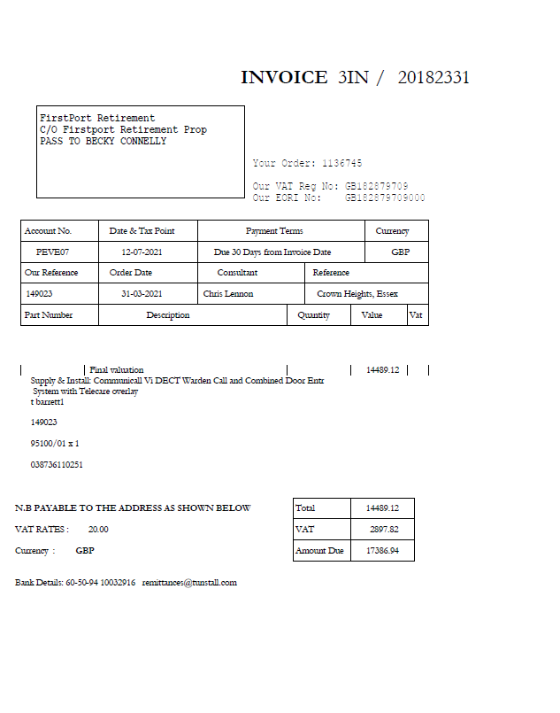

**Summary of Changes from AS IS Statement**

* Add PO Number column.
* No remittance slip (keeping only Tunstall’s bank details from this section).
* Disclaimer text hard coded onto document. “Partial Statement of Account - this may not include all open items currently on your account”

**Trigger of Report**

How is this report generated/selected?

# Document Formatting

All text fonts and colours should be as per company branding:

Text Font: Headers should use **Calibri Bold (Body)** , all other text font Calibri (Body).

Text colour should be black.

Document Name: Project Invoice

# IFS Project Invoice (PRJ INV) Report Annotated

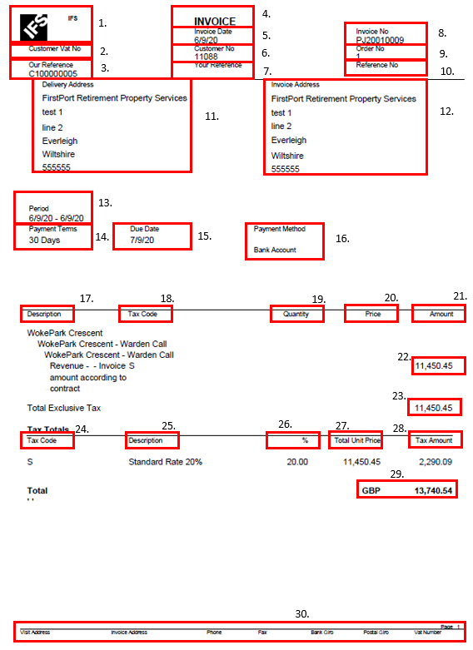

# Column Order

The next section shows the breakdown of the IFS Project Invoice. The section will detail the location of each components of the report.

|  |  |  |  |
| --- | --- | --- | --- |
| **Field ID** | **Field Name** | **Field Name / Data Source** | **Additional Notes** |
| 1 | REMOVE – IFS logo and text | REMOVE – Remove IFS logo and text.  Add the below. |  |
| 2 | Customer VAT No. | No changes. |  |
| 3 | Our Reference | No changes. |  |
| ~~1~~ | ~~Bank Details~~ | ~~Tunstall’s bank details must be included in this statement so that Customer’s know what bank details to use when they pay Tunstall. Send where this data is located in IFS.~~ | ~~This must be included in the report.~~ |
| 1.6 | Email address. | Remittances@tunstall.com |  |
| 2 | Document Name | Move to under the logo (see field 3) |  |
| 3 | Logo |  | This should be located at the far right of the header.  “Customer Statement of Account” should be located under the logo. |
| 4 | Document Title | **Document Title = “Project Invoice”** |  |
| 5 | Page No. | If more than one page then “Page 1 of X” | Current page in the report plus any other |
| 6 | Statement Balance Date | This is the date that the statement was generated. | Automatically set to today, unless specified otherwise. |
| 7 | Customer ID |  | ID of the customer for that statement. |
| 8 | Currency | Currency on the ledger item? Nope.  Curency – | The currency that the invoices are due. |
| 9 | REMOVE | REMOVE | Remove the Tax Numbe field. |
| 10 | Customer Name |  | Customer Name.  The customer name should be located above the Customer Address (disccused in the next seetion). |
| 11 | Delivery Address | Switch 11 and 12 around.  Delivery address should be on the right of the report. |  |
| 12 | Invice Address. | Switch 11 and 12 around.  Delivery address should be on the left of the report. |  |
| 13 | Document Number | Column Header called “Document Number”. Containing the list of Open Item Documents within the Customer Analysis screen.  The below shows the same data at invoice level. | The unique ID for an Invoice. Include the Invoice Number as well as the Invoice Series ID. |
|  |  |  |  |
| 14 | REMOVE | REMOVE “Int. ID” column | REMOVE |
| 15 | Document Date | This column requires data for every invoice in the customer analysis screen. It must contain the Date Date for every open invoice on the customer’s account. | Rename to “Invoice Date” |
| 16 | Due Date | This column requires data for every invoice in the customer analysis screen. It must contain the Due Date for every open invoice on the customer’s account. |  |
| 17 | Reminder Date- REMOVE | Remove Reminder Date Column |  |
| 18 | Reminder Level- REMOVE | Remove Reminder Level Column | The date that the invoice ammount is due for payment by. |
| 19 | Document Ammount – Invoice Ammount | This column will show the Invoice Amounts on the Invoices. |  |
| 19.5 | New Column = Balance | This column will show the Open Amount/Balance on an Invoice. |  |
| 20 | Debit Amount | If the Document Amount/Balance column (see field 19) is postive e.g. “100” then it is a debit amount and should be shown in this column. | Debit Lines for the invoice. These columns are in the IFS report already. |
| 21 | Credit Amount | If the Document Amount/Balance (see field 19) is negative e.g. “-100” then the it is a credit amount and should be shown in this column. | Credit for the invoice. These columns are in the IFS report already see the IFS example for more details. |
| 22 | REMOVE | REMOVE – Balance Date |  |
| 25 | Total Amount Due - | Sum of items in the balance column. | Located under the Balance column. This is the total of all invoices on the Statement. Sum of all the invoice balances. |
| 23 | Remove | Debit Total. Please remove. |  |
| 24 | Remove | Credit total Total. Please remove. |  |
| 26 | Ageing Buckets | The below screenshot shows the Aging Buckets on the current statement and how they’re set out. This must be replicated but with the data from the above screenshot in IFS. | Ageing Buckets 1,2,3,4,5,6 must be included.  Names of buckets should be set out as per the below screenshot to the left. i.e “Current”, “30 DAYS” etc. |
| 30 | Tunstall Document footer | Remove 1-7.  Add Page Number. “1 of 3”  Add a Bank Details field that shows the Account No and Sort Code based on the logic below.  **The Bank Details fields** must be filled in via an event. When this report is generated the event checks to see whether or not the “OVERWRITE_INVOICE” field is populated. See the below screenshot for location.    If this field is not blank, please fill the Bank Details Fields in with the Sort Code (ACCOUNT_REFERENCE) and Account number (ACCOUNT_IDENTITY) from the corresponding record stored here from the Cash Accounts screen.    If the “OVERWRITE_INVOICE” field is blank for that Customer. Use the “DEFAULT_INVOICE” field from the Company screen for the company that the statement is being generated for.    Populate the Bank Details Fields in with the Sort Code (ACCOUNT_REFERENCE) and Account number (ACCOUNT_IDENTITY) from the corresponding record stored in here from the Cash Accounts screen. | These custom fields were created as part of CRIM 0562  SAME LOGIC AS IN FULL STATEMENT SPEC (C0331) |
|  |  |  |  |

Technical.

Field Definitions.

<New Field/CLU Definition>

|  |  |  |  |  |  |  |
| --- | --- | --- | --- | --- | --- | --- |
| New DB Object Name | DB Object Item/Field Names | Item Description | Item Data Type | Item Syntax | Calculation Spec, if Derived | LOVs/Enums/Is Mandatory? |
|  |  |  |  |  |  |  |
|  |  |  |  |  |  |  |
|  |  |  |  |  |  |  |
|  |  |  |  |  |  |  |
|  |  |  |  |  |  |  |
|  |  |  |  |  |  |  |
|  |  |  |  |  |  |  |
|  |  |  |  |  |  |  |
|  |  |  |  |  |  |  |
|  |  |  |  |  |  |  |
|  |  |  |  |  |  |  |
|  |  |  |  |  |  |  |

Security

<Define security controls> (Who needs access to this and will it be restricted from any other users etc)

* Finance Manager.
* Credit Manager.
* Credit Controllers.

Companies

Applies to the following companies. All.

|  |  |
| --- | --- |
| **Company** | **Required (Y/N)** |
| 1201 | Y |
| TBC |  |
|  |  |

Data Migration

<Describe any data migration impacts this development may have – i.e additional data to be migrated>

Test Steps

<Steps that needs to be taken to test this change. Please provide expected results> Updated post solution.

|  |  |  |
| --- | --- | --- |
| **No** | **Script\Test Steps** | **Expected Result** |
| 1 | Open a Partial Statement of Account report. | See the fields as detailed in the Solution Detail table. |
| 2 |  |  |
|  |  |  |
|  |  |  |
|  |  |  |
|  |  |  |

Technical Implementation

<Completed by the technical developer - Technical solution, list packages, functions, Custom menus created etc >